**Thermal MR - High peak/average power transmit/receive switch**

Assembly Documentation

**Revision 1.0**

Revision History

|  |  |  |  |
| --- | --- | --- | --- |
| **Rev.** | **Date**  **(YYYY-MM-DD)** | **Description of Change** | **Author/**  **Contributors** |
| 1.0 | 2018-04-27 | Initial version | Yiyi Ji  Werner Hoffmann  Lukas Winter |
|  |  |  |  |
|  |  |  |  |
|  |  |  |  |
|  |  |  |  |
|  |  |  |  |
|  |  |  |  |

Notes:

* {} used to indicate TBD or items to be filled in before spec is finalized
* Use O.X where X is rev for pre release
* Put any additional notes below; that you want others working on this spec to note

Outstanding issues/ Questions:

* Please note that the insertion loss (transmission/reception) in this assembled version of the T/R switch is slightly better (~ -57dB) than in the published (~ -40dB) version.

**ABOUT**

Please find below the documentation to assemble a high peak/average power transmit/receive switch (v1.0) for B=7.0T (f=297MHz) [1]. If you find any flaws or if you have any questions/suggestions with regards to this document or project please let us know [info@opensourceimaging.org](mailto:info@opensourceimaging.org). Improving the quality of this work and its documentation makes it easier for others to reproduce and build upon this work.

Documentation published describing Hardware is licensed under the CERN OHL v. 1.2. You may redistribute and modify this documentation under the terms of the CERN OHL v.1.2. (<http://ohwr.org/cernohl>) except otherwise stated.

This documentation is distributed WITHOUT ANY EXPRESS OR IMPLIED WARRANTY, INCLUDING OF MERCHANTABILITY, SATISFACTORY QUALITY AND FITNESS FOR A PARTICULAR PURPOSE. Please see the CERN OHL v.1.2 for applicable conditions.

If you find the Thermal MR switch useful in your work, please cite this paper:

[1] Ji Y, Hoffmann W, Pham M, et al. High peak and high average radiofrequency power transmit/receive switch for thermal magnetic resonance. Magn Reson Med. 2018;00:1–10. https://doi.org/10.1002/mrm.27194

**Introduction**

This transmit/receive (Tx/Rx) switch consists mainly in two PIN diodes and three quarter-wavelength (λ/4) stubs. The strategical placement of the λ/4 stubs routes the high power transmitted RF signal directly from the transmission port to the RF coil/antenna without passing through any electronic components. This design enables the use of high average powers for RF heating and high peak powers for MR imaging.

O:\Users\Yiyi\09_Manuscrip preparation\TR switch\switch paper review\Figures\R2\Figure1.tif

**Figure 1** – Circuit diagram of the high-power Tx/Rx switch. Capacitors C1 and C2 and inductors L1 and L2 were used to block DC and RF, respectively. D1 and D2 are PIN diodes. The parallel circuit L3+C3 (297MHz) creates DC ground for D1 and blocks RF from DC ground. The inductor L4 creates DC ground for D2 and acts as an RF choke. The cable shield of the λ/4 stubs is connected to ground at point A. At point B, a frequency selective RF ground is provided by the series resonant circuit L5+C4, with L5 being the self-inductance of the cable shield. During the transmission mode, the PIN diodes are forward biased; the low impedance at points 1 and 4 is transformed into high impedance at points 2 and 3 by the λ/4 stubs. In this way, the RF signal from Tx port is routed into the RF coil/antenna without passing through PIN diodes. During the receive mode, the PIN diodes are reverse biased; the high impedance at point 1 is transformed into low impedance at point 2 and again to high impedance at point 3 by the λ/4 stubs, routing the received RF signal from the RF coil/antenna into the Rx port .

A more detailed description of the switch can be found in:

Ji Y, Hoffmann W, Pham M, et al. High peak and high average radiofrequency power transmit/receive switch for thermal magnetic resonance. Magn Reson Med. 2018;00:1–10. <https://doi.org/10.1002/mrm.27194>

The partlist can be found in the bill of material (BoM) v1.0 file.

**Assembly of high power transmit/receive switch for Thermal MR**

1. **Quarter wavelength stubs**

Three quarter wavelength stubs are connected to two SMA T-connectors (No.9, BoM v1.0) as displayed in Figure 2. For the quarter wavelength stubs we used Sucoform 141 Cu 50 Ω from Huber+Suhner (No. 2, BoM v1.0). The middle λ/4 stub has a male SMA connector (No. 10, BoM v1.0) at each end while the other two are connected over a female SMA connector (No. 11, BoM v1.0) to the T-connectors. The T-connectors resemble point 2 and 3 in the schematic diagram (Figure 1). For the middle stub the λ/4 length is determined from the middle of one T-connector to the middle of the other T-connector, while for the other stubs λ/4 is determined from the middle of the T-connector to the end of the outer shield of the cable (Figure 2).

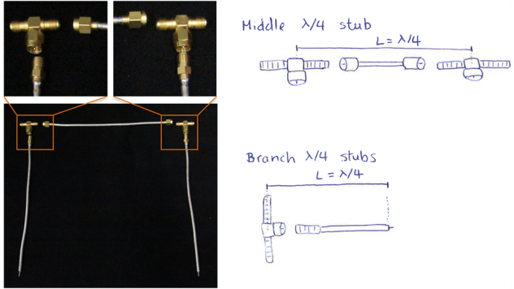

**Figure 2** – Left: SMA connectors of the cables. Right: length of quarter wavelength of the stubs.

In order to approximate the cable length to reach a quarter-wave length, the following formula can be used:

$$λ=v_{p}\frac{c}{f}$$

$λ$ is the wavelength, $v_{p}$ the velocity of signal propagation of the cable, $c$ the speed of the light and $f$ the frequency. In our case, $v_{p}$ = 0.71 and $f$ = 297.1 MHz and result in λ/4 = 17.9 cm. This is a theoretical value and can be different in reality, but it is a good starting point.

* 1. **Measuring λ/4 length**

In order to measure the correct λ/4 length a vector network analyzer (VNA) can be used. There are different ways to do so e.g. by S11 or S12 measurements, checking the smith chart or the phase measurement option from the VNA. Whatever option is chosen, proper VNA calibration is essential since minor mistakes might lead to significant phase differences at 300MHz. In order to determine the phase of the cables, we used S11 measurements. λ/4 denotes 90° phase (S11 will display 180°, i.e. 2 x phase, as it adds the phases of incident and reflected waves) or a complete (180°) rotation in the Smith chart, meaning that an open is transformed into a short.

**1.1.1 VNA calibration**

After setting the working frequency (*f* = 297.1 MHz, in our case) and the measurement span (we used 70 MHz), the calibration procedure requires an open, short and 50Ω load with SMA connectors. For accurate measurements the calibration point is important. E.g. if we want to measure just the middle stub cable that has male SMA connectors, our calibration point should be a female SMA connector for the open/short state (see Figure 3). If a particular set of connectors is missing, vector network analyzers also have typically the option to adjust phase delays e.g. introduced by connectors, which is an alternative.

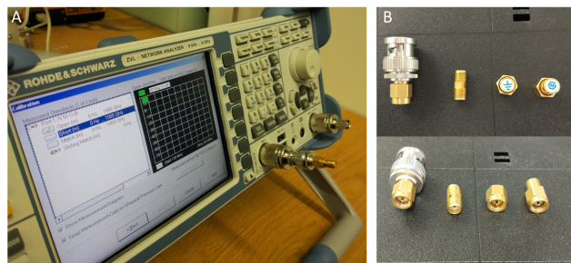

**Figure 3** – Vector network analyzer calibration. **A:** Open calibration. **B:** Detail of the connectors and SMA calibration kit used for open, short and 50Ω.

**1.1.2 Middle λ/4 stub**

The VNA calibration point was a female SMA connector (Figure 3), which was connected to the middle stub cable and a T-connector (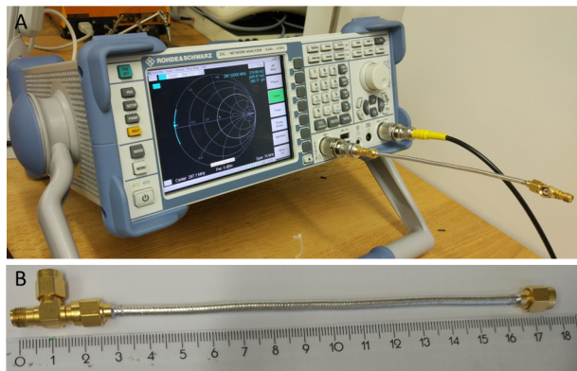

Figure **4**). Since the λ/4 length of the middle stub is defined from the middle of one T-connector (1/2 T-connector length) to the middle of another T-connector (1/2 T-connector length) (**Figure 2**), one T-connector (1/2+1/2=1) is sufficient to determine the needed phase. We used a cable length of 15.6cm that together with the T-connectors (****

**Figure 4**) has a total length of 17.5cm (theoretical value 17.9cm). Manufacturing the cable lengths might be an iterative process to reach the target phase accurately.

****

**Figure 4** – **A:** Measurement of the middle λ/4 stub. **B:** Length of the middle λ/4 stub; the cable length was 15.6cm (SMA male connector to SMA male connector). With the T-connector, the total length was 17.5cm.

When connected to the network analyzer, we could see in the smith chart that the middle λ/4 stub transformed an open into a short (Figure 5). S11 displayed a phase of 179.3°, thus, the phase of the cable was 90.3° (Figure 6).

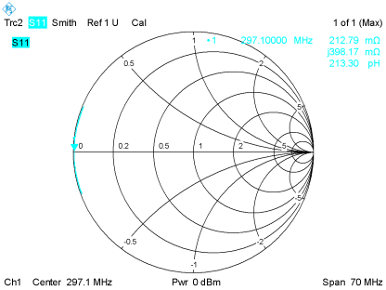

**Figure 5** – Smith chart representation of S11 measurements of the middle stub. When the middle λ/4 stub is connected, an open is transformed into a short.

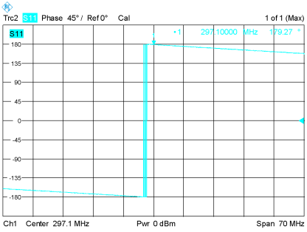

**Figure 6** – S11 Phase measurements of the middle stub. The phase at our working frequency was 179.3 (positive phase indicates that 180° has been exceeded. In this case the phase of the incident wave and reflected wave was -180°-179.3°=180.7°), thus, the cable plus T-connector has 90.3°.

**1.1.3 Branch λ/4 stubs**

The λ/4 length of the two branches is defined from the middle of one T-connector to the end of the outer shield of the cable (Figure 2). For the measurement we removed the SMA-SMA (female-female) connector used in the open calibration of the VNA and connected a T-connector with a branch λ/4 stub (see Figure 7). We used a 16.7 cm cable length, measured from SMA female connector to the end of the outer shield of the cable. With the T-connector the total length was 17.9 cm plus 4 mm of exposed inner conductor.

**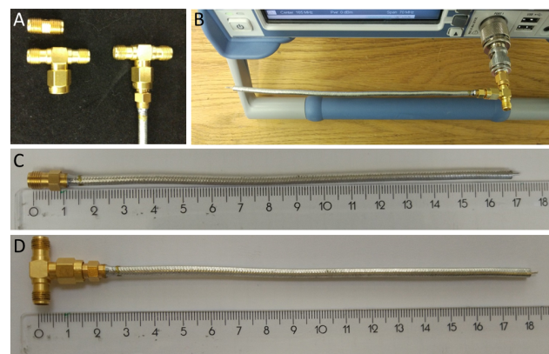**

**Figure 7** – **A:** Connectors used for the measurement of leg λ/4 stubs. As the SMA-SMA (female-female) connector used for open calibration (

Figure **3**) has similar length of one end of a T-connector to its middle, and as we want to measure L= λ/4 from the middle of a T-connector to the end of the outer shield of the cable, we removed the SMA-SMA (female-female) connector and connected a T-connector instead. **B:** Measurement of a branch λ/4 stub. **C:** the length of the branch λ/4 stub was 16.7 cm from SMA female connector to the end of the outer shield of the cable. **D:** with the T-connector the total length was 17.9 cm plus 4 mm of exposed inner conductor.

When connected to the VNA, we could see in the smith chart that the branch λ/4 stub transformed an open into a short (Figure 8). S11 displayed a phase of 179.6° (Figure 9), thus, the phase of the cable is 89.3°.

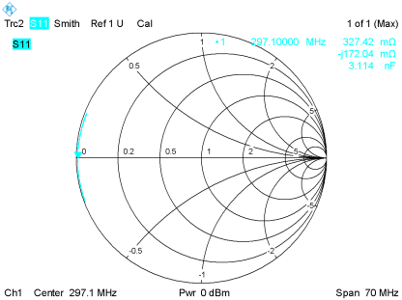

**Figure 8** – S11 measurements of the branch stub in Smith chart representation. After connecting the stub, the open is transformed into a short.

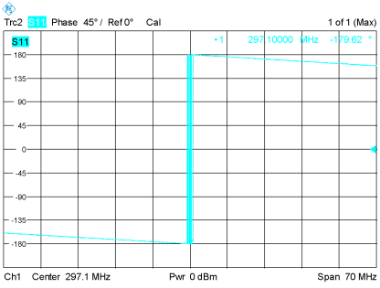

**Figure 9** – S11 phase measurements of a branch stub. The phase at our working frequency was -179.6°, i.e. the cable pluss T-connector has 89.8°.

1. **Assembly of the switch**
   1. **Base plate**

We used a (110x135)mm² board of a 2mm thick double-sided copper PCB (No.15, BoM v1.0). In order to avoid injuries, you can chamfer the corners with a rasp. We then fixed the board to a (165x125x75)mm3 casing (No.1, BoM v1.0). The casing box has holes where the board can be fixed. For an easy match of the holes, you can cut a (110x135)mm2 piece of paper where you indicate the position of the holes with a pen. Overlaying this paper on the board, you can now accurately drill the holes using a 3mm drill (Figure 10).

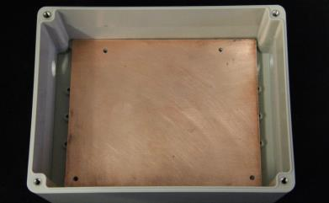

**Figure 10** – Casing and (110x135)mm2 copper base plate, where the circuit of the T/R switch will be mounted on.

* 1. **Bending the cables**

We have bended the λ/4 stubs so that they can fit in the casing box. For that we have used a semi-rigid bending tool (R282.102.000, Radiall) adjusted to the radius 19 mm, but you could e.g. also use a 3D printed cylinder for bending.

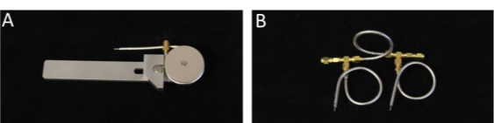

**Figure 11** – **A:** Semi-rigid bending tool (R282.102.000, Radiall). **B:** Bent and assembled λ/4 stubs (1x middle stub, 2x branch stubs).

* 1. **Connector holes for Tx port, Rx port and RF antenna/coil**

For the SMA-BNC connectors (No.13, BoM v1.0) make 12mm holes on the sides of the casing box. On the left side the center of the hole should be at x=2.7cm and y=1.7cm (Figure 12). On the right side the center of the hole should be at x=2.2cm and y=1.7cm (Figure 12). The small shift in horizontal direction (x) accommodates better the geometry of the middle λ/4 stub.

Please note that in this documentation the connector hole for the Rx-port is missing.

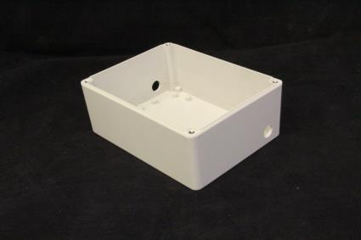

**Left**

**Right**

**Figure 12** – Casing with holes (12mm) at each side for the SMA-BNC connectors to connect Tx port and RF antenna/coil port of the switch.

* 1. **Copper sheet for heat dissipation and ceramic capacitors**

Cut two (25x40)mm² rectangles from a 1mm thick copper sheet for heat dissipation (No. 16 BoM v1.0). Chamfer the corners with a rasp to avoid injuries. On one side of each copper sheet we are going to solder one PIN diode (No.3, BoM v1.0) and on the other side five 470nF capacitors (No.4, BoM v1.0) as arranged in Figure 13.

The capacitors were soldered first as they would be facing down and connected to the base plate. First arrange them making sure that one of them is right beneath where the PIN diode is going to be soldered. This offers the shortest way to the ground for the RF signal when the PIN diode is forward biased, thus avoiding extra inductance in the copper plate. After placing some tin at the location, where the capacitors are to be soldered, we heated up the whole copper plate with a hot plate and placed the capacitors one by one on the tin (Figure 13, please note that we have used an induction cooker together with a pot). This process was much faster and less frustrating than by just using a soldering iron (it is more difficult to heat up the copper sheet properly using a soldering iron because of its good heat dissipation). After cooling down, we cleaned up the surface of the copper sheet using a PCB scrub block (SENO Polibloc).

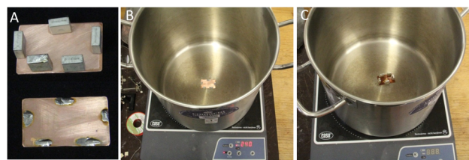

**Figure 13** – **A:** Arrangements of the ceramic capacitors on the copper sheet and the tin placed at the capacitor soldering locations. **B:** Induction hot plate and pot setup for easier and faster soldering. **C:** After tin starts to melt, place the capacitors one by one on the according locations and let it cool down.

* 1. **Soldering the copper sheet to the base plate**

Before soldering the copper sheet with the capacitors to the base board, check where it should be placed by assembling the cables and position the trimmers and front compartmentation wall (11x2.5 cm2, No.15, BoM v1.0) into the box (Figure 14). Mark also in the front compartmentation wall where λ/4 stubs will pass. The stubs will later be soldered on the PIN diodes.

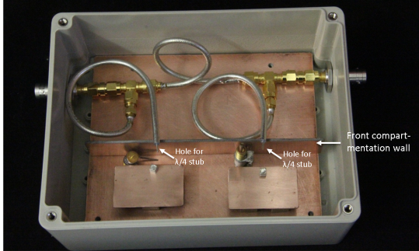

**Figure 14** – Assembled cables together with trimmer and compartmentation wall positioned (not soldered yet) in the casing box.

Place some tin on the marked places for the capacitors and then solder them to the board. Since the base plate is a PCB board (copper on top of FR-4), using a soldering iron is sufficient.

**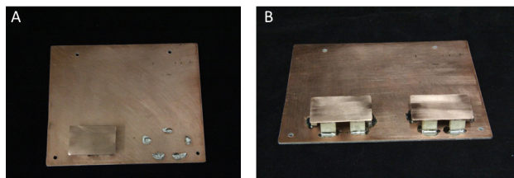Figure 15** – **A**: Tin on the marked places for the capacitors. **B**: soldered capacitors with copper sheet.

* 1. **PIN diodes D1/D2 and trimmers C3/C4**

First solder the PIN diodes (No. 3 BoM v1.0) on the copper sheet, right on top of a ceramic capacitor. Make sure that the cathode (marked with a black line in the PIN diodes we used) is facing up. Then solder one end of the trim capacitor C3 (No. 5 BoM v1.0) and inductor L3 to the base plate and the other to the cathode of PIN diode D1. Solder one end of the trim capacitator C4 (No.6, BoM v1.0) to the base plate. L3 was made of three turns of 1mm thick copper wire (No.8, BoM v1.0) around a 4.5mm cylinder (we used a 4.5mm drill, 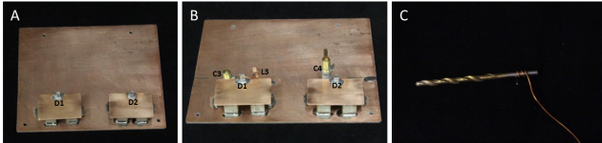Figure **16**). The measured inductance of L3 was 50nH @ f=297.1MHz. If the copper wire has an isolated coating, make sure to remove it before soldering.

**Figure 16** – **A:** Soldered PIN diodes D1 and D2. **B:** Soldered C3, L3 and C4. **C:** Manufacturing process of L3 consisting of 1mm thick copper wire and three turns around a 4.5 mm drill. L3 has a measured inductance of 50 nH at 297.1 MHz.

* 1. **Compartmentation walls**

First solder the front compartmentation wall (Figure 17) to the base plate. Before soldering the wall, drill the previously marked holes (step 2.5). We made a 4mm hole for the left branch λ/4 stub (the one on the Tx-port side) and two 6mm adjacent holes for the right branch (the one on the RF coil/antenna port side). Open the space between two 6mm holes with a rasp so that the final hole is an ellipse (major axis = 12 mm, minor axis = 6mm). Solder the outer shield of the right branch λ/4 cable and the Rx-port cable together (Figure 17 C). Using heat shrinking isolation makes sure that the outer shielding of the cables are connected to the ground only over the trim capacitor C4.

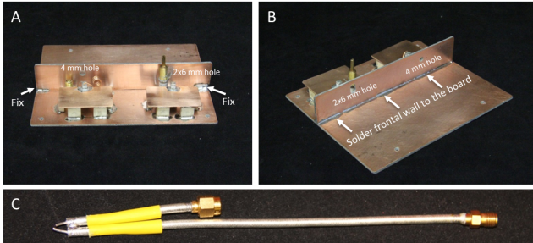

**Figure 17** – **A:** In order to solder the front compartmentation wall to the base plate, you can fix it first to the base plate using some tin at the corners. **B:** After the fixation, solder the remaining parts to the base plate. **C:**Right branch λ/4 cable and Rx-port cable soldered together at the end with heat shrinking isolation used around each. This cable will pass through 2x6mm hole.

Next, calculate the lengths of the middle compartmentation wall (No.15, BoM v1.0) leaving out a ~3mm gap towards the end of the base plate (Figure 18). The 3mm gap is for placing the back wall (wall thickness 2mm) in a later step. Cut it out in the proper dimensions (in our case (4.1x2.5 cm2)) and solder it to the front compartmentation wall and the base plate.

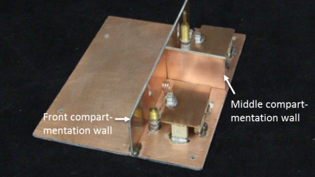

**Figure 18** – The middle compartmentation wall connected to the front compartmentation wall and the base plate.

Finally, solder the back wall (11x2.5)cm2 to the small compartmentation wall and the base plate. Before soldering, make sure to make holes for the feedthrough filters (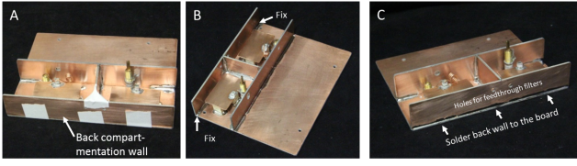Figure **19**)

**Figure 19** – **A:** Back wall fixed with tape before soldering. **B:** Fix the internal side of the back wall with some tin to the base plate. **C:** Solder the back wall to the board on the external side.

After the wall is fixed, solder the feedthrough filters (No.18, BoM v1.0) to the back wall and solder a wire to connect them outside of the back wall (Figure 20). This is the point where the DC bias voltage for the PIN diodes will be connected.

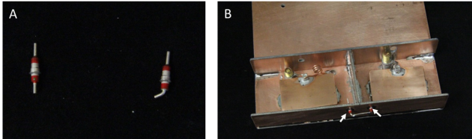

**Figure 20** – **A:** The feedthrough filters. **B:** feedthrough filters soldered to the back wall (indicated by white arrows).

* 1. **Inductors L1, L2 and L4**

Solder one end of the inductors L1 (No.7, BoM v1.0) and L2 (No.7, BoM v1.0) to the feedthrough filters and the other end to the top side of the copper sheet (where the anode of the PIN diodes was soldered). Solder one end of the inductor L4 (No.7, BoM v1.0) to the cathode of PIN diode D2 and the other end to the base plate. The inductors we used here are very small so we soldered them first on a small PCB and used additional wires Figure 21.

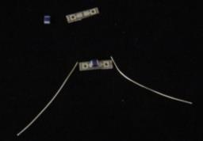

**Figure 21** – The small inductors L1, L2 and L4 were soldered on a small PCB board first, using wires to connect them to the rest of the circuit.

* 1. **Soldering the λ/4 stubs**

Solder the center conductor of the left branch stub to the cathode of PIN diode D1, and solder the outer shield to the main compartmentation wall (around the hole where it passed through). This connects the RF ground to the base plate. Then, solder the center conductor of the right branch stub and the center conductor of the Rx cable to the cathode of PIN diode D2 and solder the trimmer C4 to the outer shield of these cables (**Figure 22**). Please note that the outer shield of these two cables is not connected to the front wall. C4 and L5 (L5 being the self-inductance of the cable shield of the stubs) provide a frequency selective RF ground. Last but not least connect DC ground to the base plate.

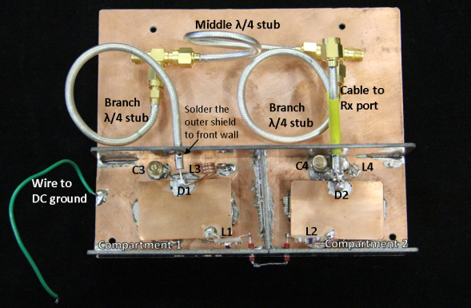

**Figure 22** – Fully assembled high power switch.

* 1. **Place the circuit in the casing**

Place the fully assembled switch in the casing. Here two extra male SMA-male SMA connectors were necessary to connect to the BNC connectors. Adjusting the dimensions of e.g. the casing would make these connectors redundant.

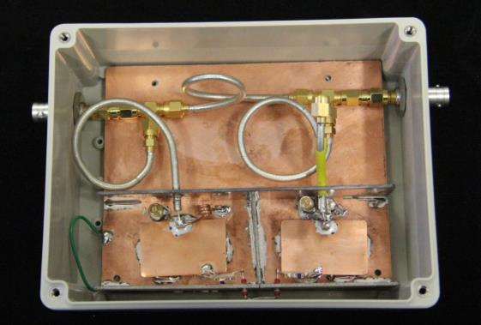

**Figure 23** – Fully assembled switch in the casing box.

1. **Bench test of the switch**

We used a vector network analyzer to characterize the performance of the switch. A DC power supply is necessary to feed the PIN diodes (forward bias: I=24-100 mA, reverse bias: V=-30V).

**3.1 Transmission mode**

Measuring the isolation: Connect the Tx-port and Rx-port to the VNA and supply I=24-100mA to the PIN diodes. Connect a 50Ω load to RF antenna/coil port.

Measuring insertion loss: Connect the Tx-port and RF antanna/coil port to the VNA and supply I=24-100mA to the PIN diodes. Connect a 50Ω load to the Rx-port.

**3.2** **Reception mode**

Measuring the isolation: Connect the Tx-port and Rx-port to the VNA and supply -30V to the PIN diodes. Connect a 50Ω load to RF antenna/coil port.

Measuring insertion loss: Connect the Rx-port and RF antanna/coil port to the VNA and supply ‑30V to the PIN diode. Connect a 50Ω load to the Tx-port.

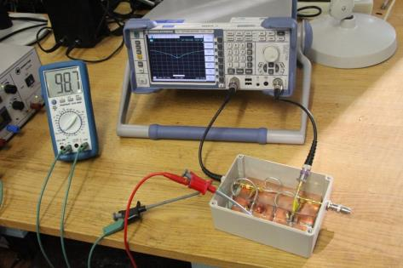

**Figure 24** – Measuring setup of the T/R switch. A two port network analyzer was used to assess isolation and insertion loss. A DC power supply was used to feed the PIN diodes.

The constructed switch used for this documentation had an isolation of -56.3dB (Figure 26) during transmission, and -57.6dB (Figure 27) during reception. The insertion loss was -0.35dB (Figure 28) during transmission and -0.21dB (Figure 29) during reception. The results are summarized in Table 1.

|  |  |  |
| --- | --- | --- |
|  | **Transmission** | **Reception** |
| **Isolation** | -56.3 dB  (Tx-port – Rx-port) | -57.6 dB  (Rx-port – Tx-port) |
| **Insertion loss** | -0.35 dB  (Tx-port – RF coil/antenna) | -0.21 dB  (RF coil/antenna – Rx-port) |

**Table 1** – Bench test results

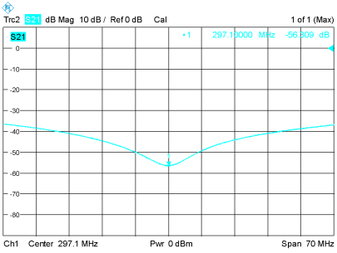

**Figure 25** – Isolation during transmission: -56.3 dB.

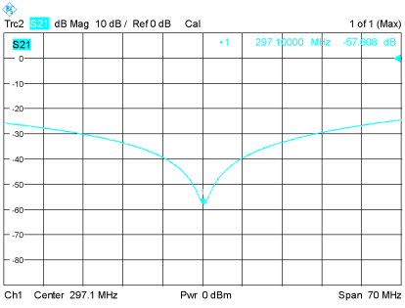

**Figure 26** – Isolation during reception: -57.6 dB.

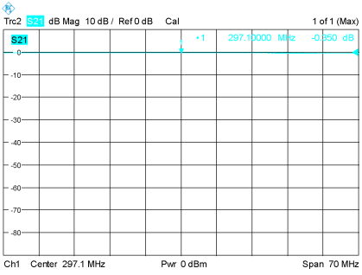

**Figure 27** – insertion loss during transmission: -0.35 dB.

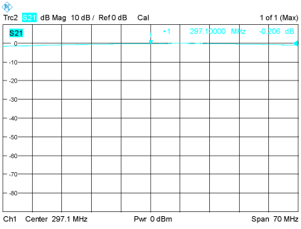

**Figure 28** – insertion loss during reception: -0.21 dB.

# Comments

Please note that you might need to take into account preamp impedance for your switch to work properly. The switch characterization performed here is based on 50Ω VNA impedance !

The price of the switch is around 500€, however no cost optimization has been performed. In order to lower the cost of the switch (<300€), the following measures can be applied:

1. The ceramic trimmers 1-40pF Number 6,( see BoM File) can be replaced with cheaper lower range trimmers such as 1-8pF Number 5 together with a fixed capacitance in parallel
2. SMA-BNC connectors (Number 13) are optional and could be replaced by cheaper SMA connectors.
3. Only the connectors used in this documentation are accounting for more than half the material cost of the switch. Just replacing these connectors by cheaper vendors, might reduce the costs drastically.